Luis 'Jerry' Ortiz, 35, sheriff's deputy killed by a gang member
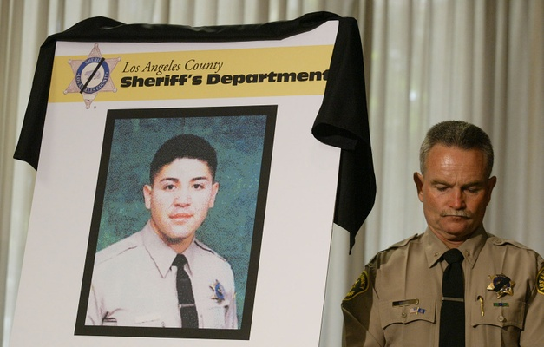
By LOS ANGELES TIMES
JUNE 24, 2005
Deputy Luis Gerardo "Jerry" Ortiz, a 35 year-old Latino, was shot and killed on June 24, 2005.
Ortiz, a gang officer, was interviewing a woman and a man outside a Hawaiian Gardens apartment when a gunman burst out of the residence, put a handgun to the officer's face and fired, authorities said.
Authorities said Ortiz probably died instantly.
"This was an assassination of a deputy," Sheriff Lee Baca said. "It was a sudden attack that gave the deputy no chance."
In 2007, Ortiz's shooter, Jose Luis Orozco, a 29-year-old Latino, was sentenced to death by a Norwalk jury. The jury had found him guilty of first-degree murder with the special circumstances of murder of a police officer and possession of a firearm by a felon.
"This is the kind of person and the kind of crime that the death penalty was made for," said Dist. Atty. Steve Cooley at the time of the sentencing.
Sheriff's Deputy Timothy Brennan, who had been Ortiz's partner for a year, called the verdict bittersweet. He explained, "You feel good, but it's never going to bring Jerry back to his family and friends."
A 15-year department veteran, Ortiz had hoped to become a detective.
He had married two weeks before the shooting, and had won a department medal of honor for fatally shooting a suspected carjacker who had pulled a gun on him and his partner.
Oct. 5, 2016: This post was updated with details of the shooting and verdict.
Photo: Commander David Betke of the Los Angeles Sheriff's Dept listens during a press conference on Ortiz's death. (Gary Friedman / Los Angeles Times)
Do you have information to share about the life of Luis 'Jerry' Gerardo Ortiz ? The Homicide Report needs your help. Please fill out this form or e-mail us at homicidereport@latimes.com.

Gang Profile: Varrio Hawaiian Gardens
Gangs • October 20, 2011 • by Richard Valdemar
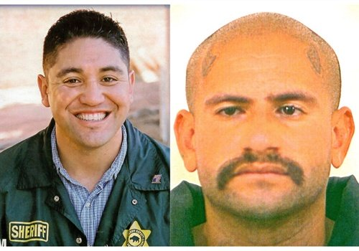
LASD Deputy Jerry Ortiz (left) and Varrio Hawaiian Gardens gang member Jose Luis "Sepy" Orozco.
Hawaiian Gardens covers one square mile in southeast Los Angeles County, and carries the distinction as the smallest city in the county. About 14,300 residents live in a town incorporated in 1964. In the 1920s, the area was rural and the city took its name from a small refreshment stand decorated with palm fronds and bamboo that sold sandwiches and soft drinks spiked with moonshine during prohibition. The local gang, Varrio Hawaiian Gardens, traces its beginnings to the 1940s and Louis "Hero Buff" Flores; the founder of the Mexican Mafia was from the Hawaiian Gardens gang. So was Alex "Hondo" Lechuga.
Most of the city's income comes from a gambling casino that generates about $9.2 million a year. Los Angeles County Fire Department provides fire services to Hawaiian Gardens and contracts with the Los Angeles County Sheriff's Department for police service.
When I worked this area, I found that the community seemed to be overly tolerant of the local Latino gangs and drug trafficking, and not so much with the police. I nicknamed Hawaiian Gardens "148 City" for the California Penal Code section for "Resisting or interfering with a peace officer in discharge of his duties." It was often the case when conducting a police investigation or making an arrest in this city that deputies would inevitably find it necessary to arrest one or two others who would intervene for the suspect and interfere with police business.
Hawaiian Gardens gang member Jose Luis Orozco used "Sepy," as his gang moniker. During the summer of 2005, he was 28, 5-foot-4-inches, and 150 pounds. The gang had adopted the cartoon character of the "Hawaiian Punch" man as their logo, and Sepy wore a tattoo of the character on his right arm. He also wore "LA" and "South Sider" tattoos on his chest and his clique name loquitos (little crazy ones) on his back. But the most telling tattoos were the devil horns on his forehead.
Sepy was a hardcore gang member with numerous juvenile and adult arrests for vehicle theft, car jacking, robbery, assault with a deadly weapon, burglary, drug possession, felon in possession of a firearm, shooting at an inhabited dwelling, and several parole violations.
Two of my teenager sons were boxers in 2005 and worked out in the ring at Deputy Mike Young's gym. Deputy Jerry Ortiz sometimes sparred with them. Jerry was a great boxer and won many victories in state and regional events. He was a gold-medal winner at the World Police Games.
Deputy Jerry Ortiz joined the LASD in February of 1990 and had obtained a position as a gang investigator with the Operation Safe Streets (OSS) Unit. He was a family man devoted to his wife Chela and his two sons. His demeanor was friendly, and his smile was infectious. His commitment to service included being an usher at the church which he faithfully attended. He was everything that Sepy Orozco was not.
The city of Hawaiian Gardens was important to both men. Deputy Ortiz worked to make the city a safer place for its citizens and their families, and Sepy Orozco wanted it as exclusive turf of the Varrio Hawaiian Gardens gang.
On June 20, an African American man was helping a friend fix up his home on Joliet Street. This was a dangerous thing to do. Varrio Hawaiian Gardens was a Sureño gang fiercely loyal to the Mexican Mafia, and the Mafia was in a racial war against Blacks. Varrio Hawaiian Gardens (HG) was also known as the "Hate Gang" because of the hate crimes it had committed against African Americans.
The African American man would later testify in court that a man with horns tattooed on his head approached him and offered to sell him drugs. When the victim refused, the horned man later identified as Orozco pulled a handgun. The victim tried to block Sepy Orozco's arm as the first bullet narrowly missed the victim's head. Orozco continued to fire the weapon, striking the victim in the shoulder and the buttocks as the victim ran away.
The OSS Gang Unit had obtained a positive identification of the suspect with horns tattooed on his head from a photo line-up shown to the victim. Now they began their search for Sepy Orozco to arrest him for the shooting.
Four days later at about 3 p.m., Deputy Jerry Ortiz was driving through Hawaiian Gardens on his way to deliver some paper work when he spotted Orozco. As Deputy Ortiz tried to stop the gang member, Orozco ran down a narrow alley toward a familiar apartment complex in the 12200 block of East 223rd St. This was the same group of apartments where Sepy had been arrested a year earlier.
Both the apartment complex and many of the people who lived there were very familiar to the experienced Deputy. As Deputy Ortiz waited for other deputies to arrive, he noticed one of the apartment doors was standing open. Ortiz knew this location and walked up to the open door and called to a female resident.
A few moments earlier, Sepy Orozco had also noticed the open door. Before Ortiz arrived, he ran inside the apartment and hid behind the open door. As the deputy approached Sepy's hiding place, the gang member shot Deputy Ortiz in the head at close range.
The newspaper of the Varrio, gang graffiti on the walls, boasted of the murder of the OSS gang deputy. "F-K the COPS 187," "F-K PIGS 187," and "Rest in Piz Ortiz" covered the walls in the area. The Hawaiian Garden homeboys even wrote the rap song about the incident. Here's an excerpt:
Another cop gone, another cop gone, is all I'm hearing—another cop gone.
Is like a MF countdown, armed and dangerous, we just go mutherfukn balls out.
Just show that we roll, and how the southeast rides,
committing all these muthafkn crimes, all at one time.
Sepy Orozco was eventually captured and convicted for the murder of Deputy Ortiz. I testified in the case. Today, Jose Louis Orozco sits on death row in San Quentin State Prison, awaiting his execution. That will never bring back what we have lost—one good gang cop.

